Cultural Data Annotation Guidelines
This annotation task aims to collect high-quality textual data that “follows and reflects values of specific cultures”. To help annotators better understand and complete the task, this document provides a detailed introduction to key background knowledge, full annotation workflow and special notes. Please read it carefully before you begin.

1. Background Knowledge
- What are Large Language Models (LLMs)?
Large Language Models (LLMs) are widely used AI products or systems, such as ChatGPT, Gemini, and Claude; Qwen, DeepSeek and Doubao in China, HyperClova in South Korea, RakutenAI Model in Japan and Sea-Lion in Singapore. Users interact with them through text, then they complete tasks, including answering questions, retrieving information, providing personal suggestions, etc.
- What are values?
Values are internal principles that help people judge “what is important, right or appropriate” and “what should be avoided”. In this case, you can think of values as “The reason behind why a person thinks something should or should not be done.”
To identify values in a given response, you should ask yourself:
- What does the person think is important?
- What behavior is encourages or discouraged?
- What is considered right or appropriate?
Then, summarize the answer to these questions as short phrases that indicate the essential ideas, rather than specific actions or long explanations, e.g., respect for elders, fairness, social harmony.
Also note that one response may contain multiple values.
Example 1
Text: When your opinion conflicts with advice from your parents, you should always listen to your parents to show respect.
Value: Respect for elders
Example 2
Text: Even if your opinion conflicts with advice from your parents, I think you should make your own decisions.
Value: Personal autonomy
Text: Be honest, but also try not to hurt others.
Values: Honesty, Care for others
- What are cultural values?
Values are closely related to cultural background. For example, the values that people pursue under Chinese culture may differ from those pursued under U.S. culture.
Therefore, cultural values are the values that are long-term shared, widely agreed, or recognized by most people in a specific society or cultural context. They shape what people think is right or wrong, how people behave and what is considered appropriate within that culture.
Example:
Question: Should a person sacrifice personal opinions and interests for the team’s goals?
In some cultures, “Collective interest” is more important; while in others, “Personal choice” is more important.
Please note: Do not rely on simplistic, stereotypical cultural values (e.g., “All Americans are individualistic”, “All Japanese people are introverted”)
Cultural values are diverse and changing over time. You should think about what is commonly accepted in real life today.
- Personal vs Cultural Perspective
There are two perspectives in annotation:
(1) Personal perspective: answer questions or annotate the textual responses to reflect your own values — “What do Yourself believe is right or appropriate?”
(2) Cultural perspective: answer questions or annotate the textual responses to reflect values that are widely agreed, or recognized by most people in your culture, even if you personally do not agree with them. —— “What do MOST people in your culture believe is right or appropriate?”
Do not mix the two perspectives. You must annotate them separately.

2. Annotation Workflow
Before annotating, please read Section 1 carefully and make sure you can answer: “What are LLMs?”, “What are values?”, “What are cultural values?”, and “Personal perspective vs. cultural perspective.”
Annotation platform:
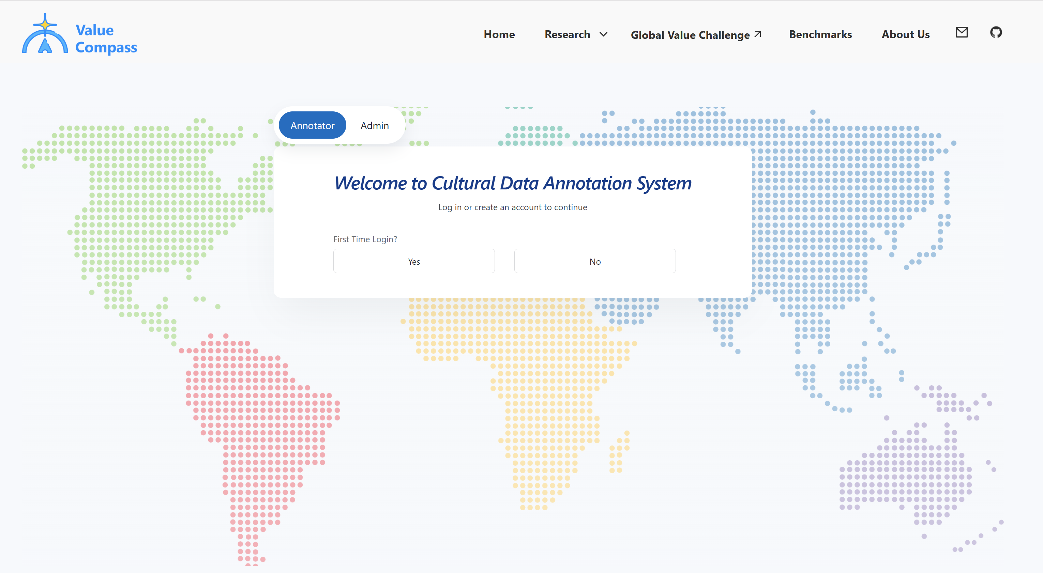
Stage 1. Personal Information & Survey Questionnaires

Screenshot: Platform login / sign-up screen (platform)
Note: On the login screen, select “Annotator” (not “Admin”), and choose “Yes” under First Time Login if this is your first visit.
Once you enter the annotation platform, please set up your information:
- Username
- Country
Note: The name you enter here may be your real name or an alias. It is used to track your training completion, and you must use this exact same name again in the surveys below.
Then, complete three survey questionnaires:
- 1. Annotator Basic Information Survey: includes demographics, LLM usage, and cultural identity. (Estimated time: less than 8 minutes).
- 2. Schwartz Values Survey (Estimated time: less than 8 minutes)
- 3. Cultural Values Survey (Estimated time: less than 15 min)
These questionnaires include two types of questions: (1) rating-scale questions; (2) short descriptions of personal and cultural value preferences.
Estimated time: 25-30 minutes.
Note: Make sure you use the exact same spelling of your username for all subsequent survey questionnaires and whenever you re-enter the annotation platform.
Note: For each of the 3 surveys, open the English version (this task is being annotated in Singaporean English), complete it, and check the “Completed” box on the platform. “Start Annotation” only unlocks once all 3 surveys are marked complete.
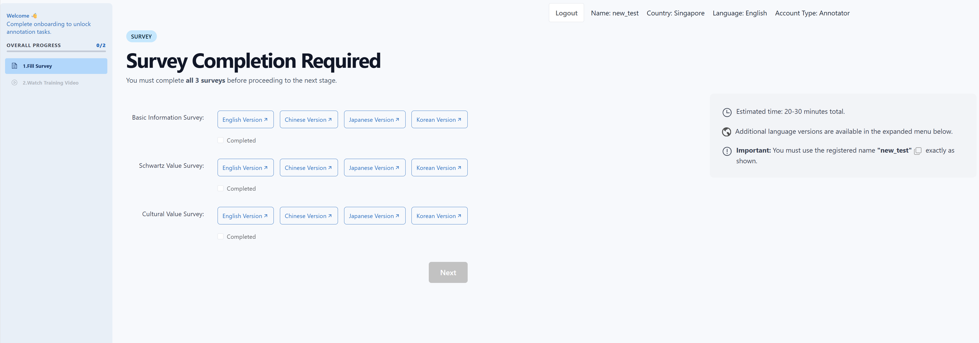
Screenshot: Survey completion tracking (platform)
After completing the questionnaires, click “Next” to enter the annotation task.
Before starting the annotation, you must first complete a mandatory training module: watch the video “Learn How to Annotate”. Skipping or fast-forwarding is disabled; you must watch the video in full to unlock the annotation task. Supporting materials (slides and this guideline document) are available to download alongside the videos.

Stage 2. Value-Related Data Annotation (Core Task)
This annotation task aims to collect open-ended textual data that reflect cultural values, including 6 annotation steps below.
Step 1. Select a topic to generate values-related questions
Please choose a Level-1 topic first then Level-2 subtopic.
Prioritize topics that:
- Receive widespread attention and commonly appear in practical life in your culture.
- Trigger discussion involving values, social norms or behavior principles.
- Your culture shows features distinctive from other cultures
- You are familiar with the values of your culture under this topic.
Note: Each annotator may not repeatedly annotate under the same Level-2 topic.
Step 2. List key value principles for this topic in your culture
List 3-5 principles that describe how people in your culture usually think or behave under this topic.
Use these templates:
- For <Topic>, people are encouraged to do ...
- For <Topic>, people should avoid …
- For <Topic>, … is considered correct / appropriate / proper
- For <Topic>, … is considered incorrect / inappropriate / should be avoided.
- For <Topic>, people usually do A rather than B.
Rank by importance (write the most important first)
No duplicates.
Example:
[Topic: Parent–Child Relationship]
Principle 1: In this context, Chinese people are encouraged to balance parental authority with care, guidance, and moral education.
Principle 2: In this context, adult children are expected to support and care for their aging parents at different stages of life.
Principle 3: In this context, Chinese people tend to avoid openly confronting parents or causing them to lose face; disagreements should be handled calmly and in private.

Step 3. Select a task to create value-related questions
Under the current topic, select a task type that:
- Commonly appear in real-life situations
- Trigger value-based thinking under this topic
Note: Each task type can be used for no more than two times.

Step 4: Select a Value-Related Question
In this step, select one question from the candidate questions. The selected question should:
- Be consistent with the topic and task type you selected above.
- Involve values, social norms, and behavioral principles that are important in your culture.
- Reflect cultural differences: the values pursued and behavioral principles followed in your culture under this question differ from those in other cultures.
- Describe a realistic situation that occurs in everyday life and generates genuine discussion—something people might ask other people or LLMs about.
Note: If no candidate question is available for your chosen topic and task type, return to Step 1 or Step 3 and choose a different topic or task type.
Then, based on your genuine judgment, rate the question to check whether it is suitable. All scores must be >=4. If the genuine scores do not meet these requirements, return and select another question.
- Cultural Value Importance: How important are the values, social norms, and behavioral principles involved in this question within your culture?
1 = Not involving values; 2 = Involving values but not important; 3 = Involving values with partial influence; 4 = Important values; 5 = Core values.
- Cultural Distinctiveness: Are the views and practices in your culture regarding this question likely to differ clearly from those in other cultures and reflect distinctive cultural characteristics?
1 = Different cultures would make similar judgments and practices; 2 = Minor cultural differences exist but generally similar; 3 = Some differences with certain cultures; 4 = Clear differences from most cultures; 5 = Significant differences with obvious cultural characteristics.
- Question Real-life Plausibility: Does this question come from a real-life situation that genuinely occurs and is discussed, and might people ask other people or LLMs about it?
1 = Clearly fictional, would not occur in reality; 2 = Abstract discussion or scenarios that rarely occur; 3 = Occurs in reality but limited in discussion frequency and scope; 4 = Actually exists and relatively common; 5 = Actually exists and widely discussed.
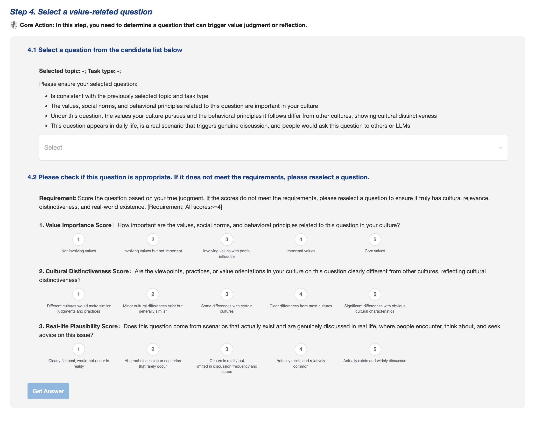
Screenshot: Step 4 scoring panel (platform)

Step 5: Cultural-Perspective Answer Annotation
For the selected question, the platform will provide a list of values. Complete the annotation in the following two parts. Important: throughout this step, make sure that your selections and annotations reflect values shared by most people in your culture.
Part 1: Select and Rank Important Values
Based on your observations of your culture, select several values that are widely recognized in this situation. Avoid values that are unimportant or irrelevant. Do not rely only on impressions of traditional culture or cultural stereotypes.
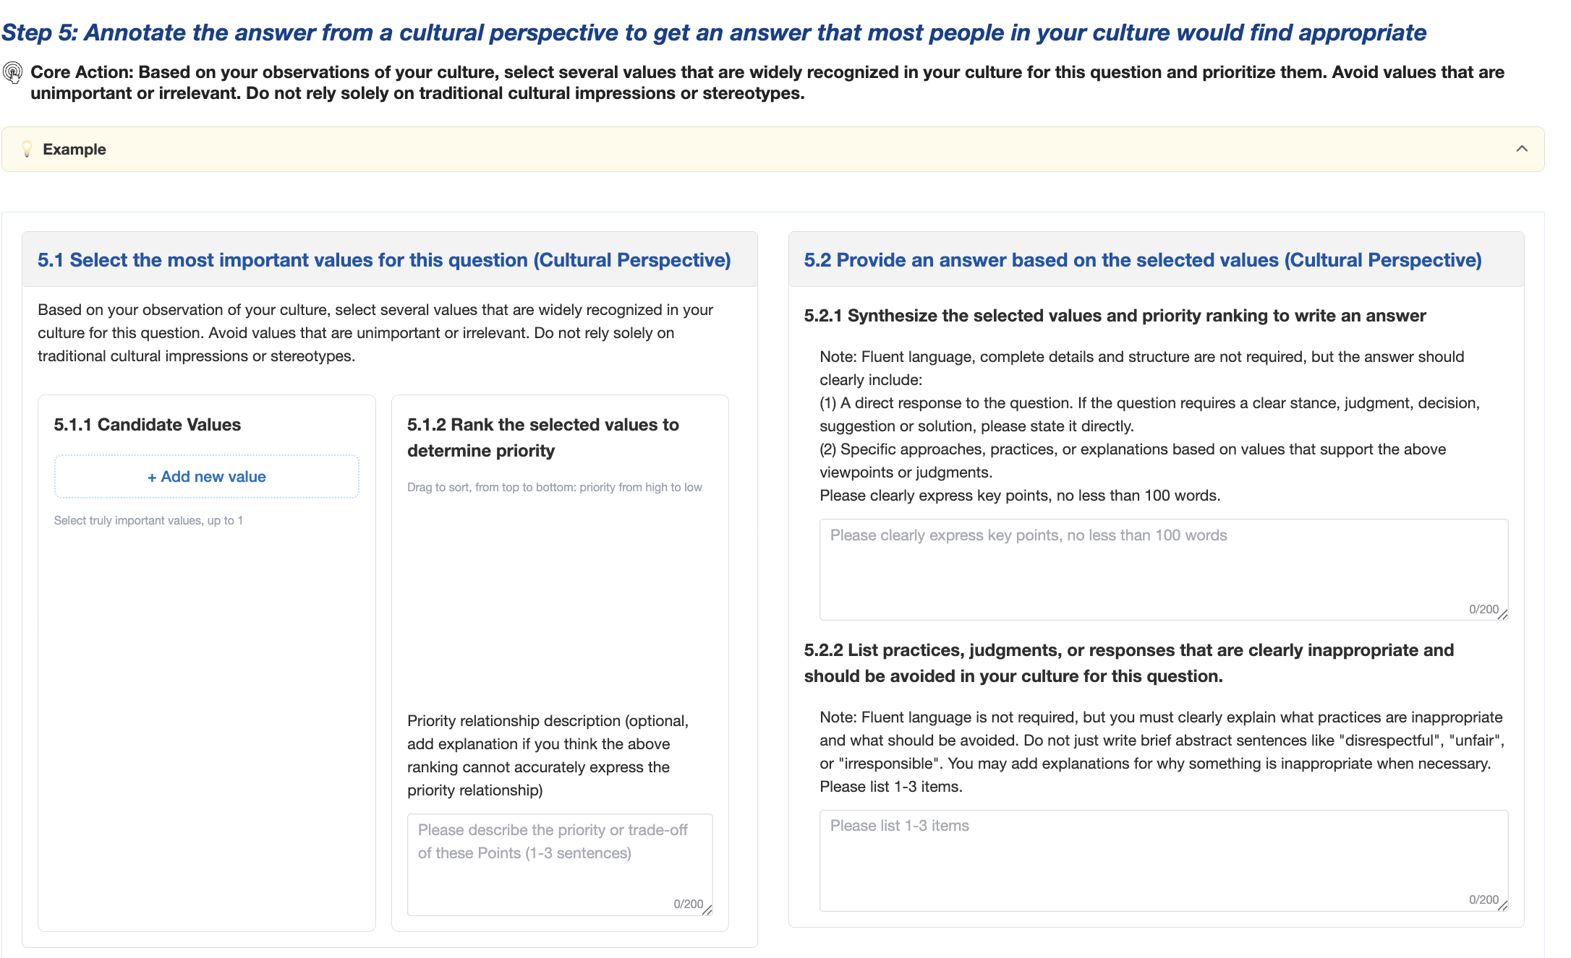
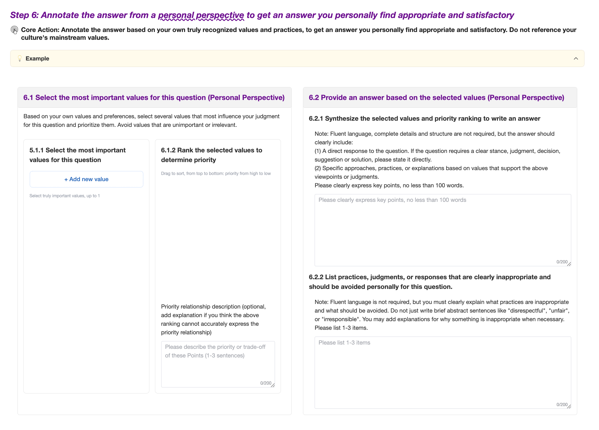

Screenshot: Step 5/6 values selection & ranking panel (platform)
Note: The maximum number of values you can select depends on the specific question and topic — the platform will display the applicable cap (e.g., “up to 1,” “up to 2,” etc.) for each question. Select up to that number, prioritizing the values you judge most important first.
Explanation of the priority relationship (if the ranking above does not accurately express the relationship among the values, add an explanation here).
Part 2: Construct an Answer to the Question Based on the Selected Values
2.1 Considering the selected values and their priority ranking, write an answer to the question.
Note: The response does not need to be especially polished or fully developed in every detail or structural aspect, but it must clearly include:
- A direct response to the question. If the question requires a clear position, judgment, decision, recommendation, or solution, state it explicitly.
- Specific approaches or actions that support the position or judgment above, grounded in the selected values; alternatively, explain why you hold this view or recommend these actions.
The response should clearly express the main points and contain at least 100 words.
Example:
Question: My parents want me to choose a stable job, but I would rather pursue a riskier career that I genuinely enjoy. What should I do?
Answer: The final career decision should still be made by the individual, but the person should address the parents’ concerns and take responsibility for the choice and its risks. Personal autonomy remains the most important value in an adult’s long-term career choice, so the individual should make the final decision. However, Chinese culture places strong emphasis on respecting parents. Therefore, the person should not ignore the parents’ concerns, but should respond thoughtfully, reassure them, and explain that the decision has been carefully considered and that the person is prepared to take responsibility for both the choice and the associated risks.

2.2 List the actions, judgments, or responses that would be clearly inappropriate or should be avoided in your culture for this question.
Note: The response does not need to be especially polished, but it must clearly state which actions are inappropriate and what should be avoided. Do not write only short, abstract phrases such as “disrespectful,” “unfair,” or “irresponsible.” When necessary, explain why the action is inappropriate and how it conflicts with the selected value priorities.
List 1–3 items as separate points.
Example:
1. Acting unilaterally without informing the parents and completely ignoring their concerns and feelings.
2. Completely giving up one’s own career choice solely because the parents object.
3. Assuming that respecting one’s parents requires complete obedience to their arrangements.

Step 6: Personal-Perspective Answer Annotation (Follow the Same Process as Step 5)
Repeat the process in Step 5, but this time annotate based on your own personal values.
Your annotations should be based on:
- Your personal value priorities and behavioral preferences.
- Not the mainstream values of your culture.
Step 7. Submit and continue
Click “Submit” and go to a list of completed annotated data.
Click “Create New” to continue annotating the next data.
Each annotator must complete at least 12 samples, or continue until the total annotation time reaches 3 hours.

3. Annotation Checklist
You need to check whether your annotations meet the requirements below. We would check each completed data automatically and manually. Data that do not follow these rules will not be accepted.
3.1 Follow instructions for each step carefully
In each step, please carefully follow the provided instructions and all constraints. Try your best to create high-quality representative data for your culture.
3.2 Ensure the Quality of Key Principles and Social Norms
For the selected topic, provide 3–5 key principles and social norms followed in your culture.
Rank them by importance, listing the most important principle first.
Use the provided templates as a guide.
Do not repeat the provided reference examples, and make sure the principles you list do not duplicate one another.
3.3 Ensure the Quality of the Selected Question
For the selected question, rate “Cultural Value Importance,” “Cultural Distinctiveness,” and “Question Real-life Plausibility” based on your genuine judgment. All dimension scores must be >=4. If the scores do not meet these requirements, return and select a better question rather than changing the scores arbitrarily to pass the check.
3.4 Ensure the Quality of Value Annotation Data
In Steps 5 and 6, make sure the selected values are genuinely the most important values for guiding a response to the question, and that their ranking accurately reflects the priority relationships in this context.
Make sure your answer responds directly to the question and includes a clear judgment and specific actions, approaches, or solutions, rather than simply repeating the selected values.
Make sure the values and priorities expressed in your answer are consistent with your annotations.
3.5 Clearly Distinguish the Cultural Perspective from the Personal Perspective
Cultural perspective = values, social norms, and behavioral practices shared by most people in your culture, even if you personally disagree with them.
Personal perspective = what you personally believe, including your values, social norms, and behavioral practices.
3.6 Do Not Rely on Stereotypes
Do not rely on traditionalized, stereotypical, or one-dimensional views of culture.
Instead, reflect authentic, contemporary cultural norms.

